# **How To Edit Temp and Humidity Logs from Facilities**

|  |
| --- |
|  |

1. Select the whole table

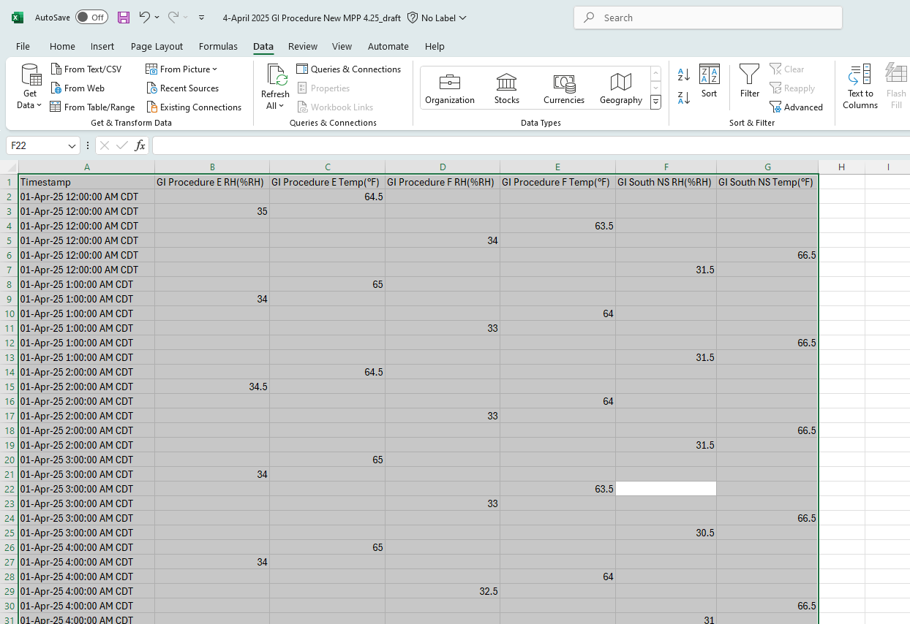

1. Click on the "Data" tab from the top

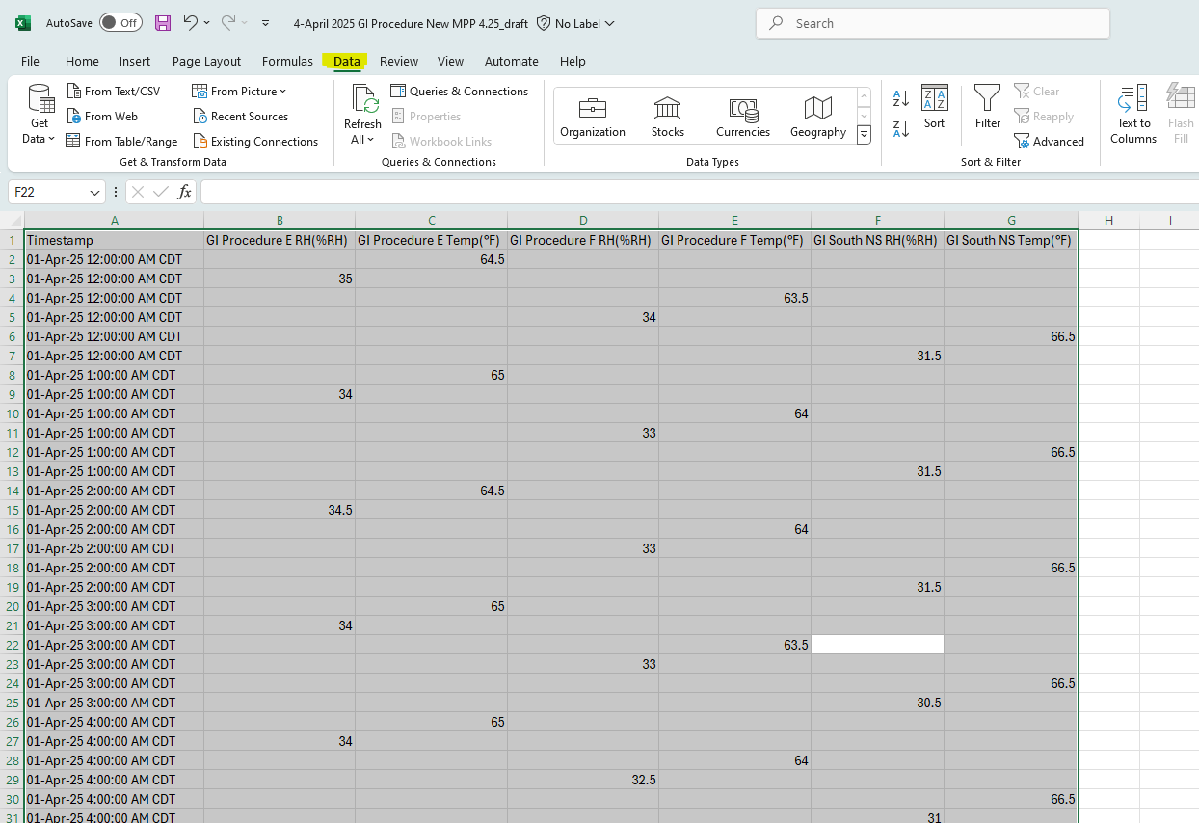

1. Click "From Table/Range"

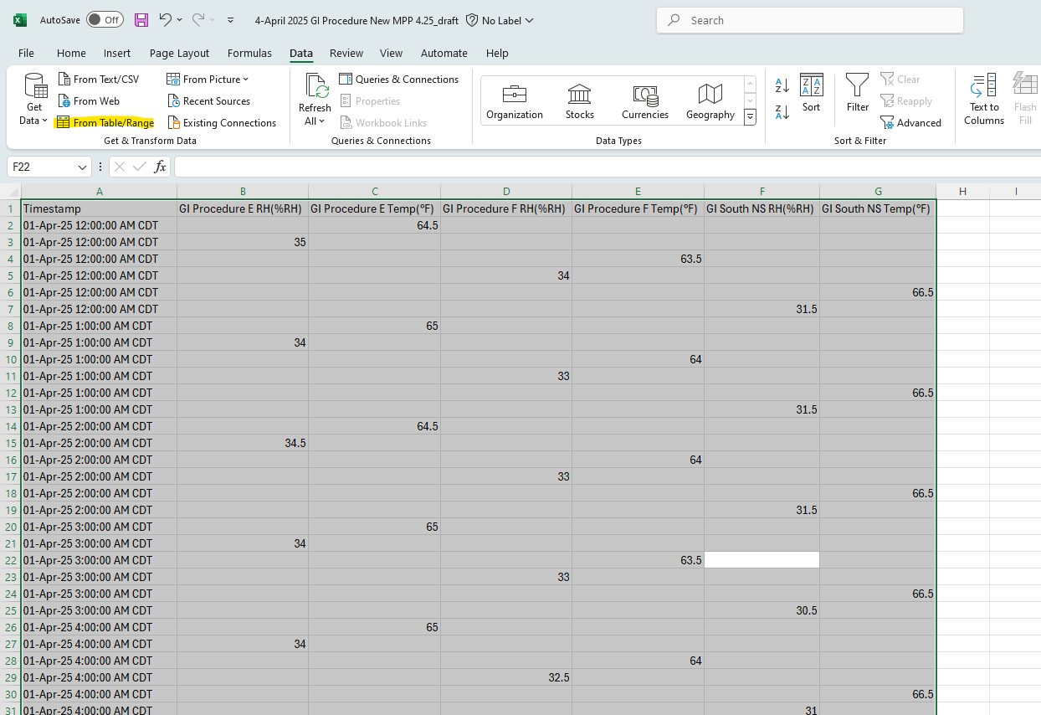

1. A dialog box should appear with the range of the selected data

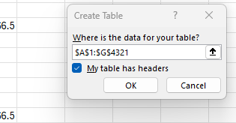

* 1. Make sure "My table has headers" is selected

1. Power Query then opens a new window

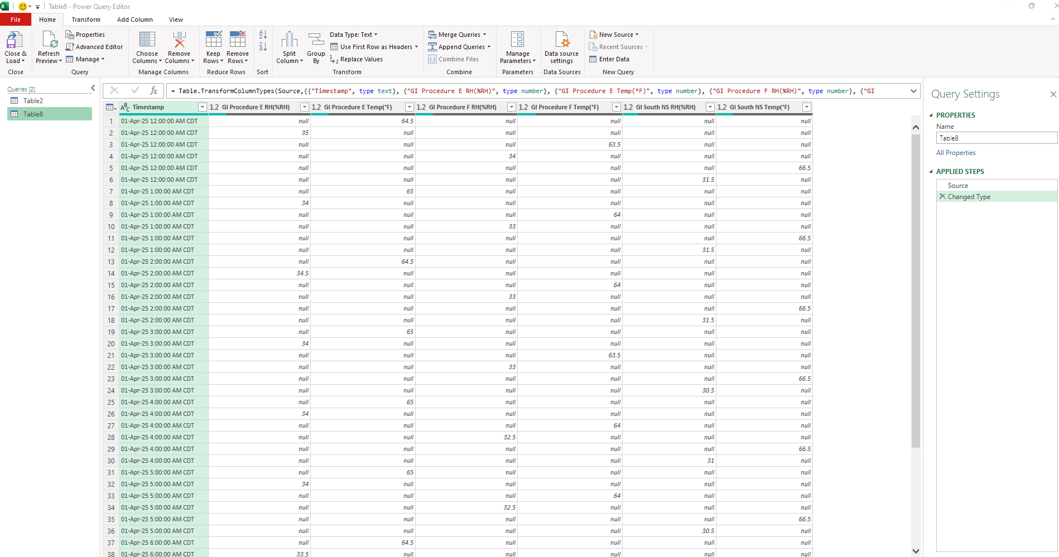

1. Click the down arrow for the function and paste the function below in its entirety into the function box

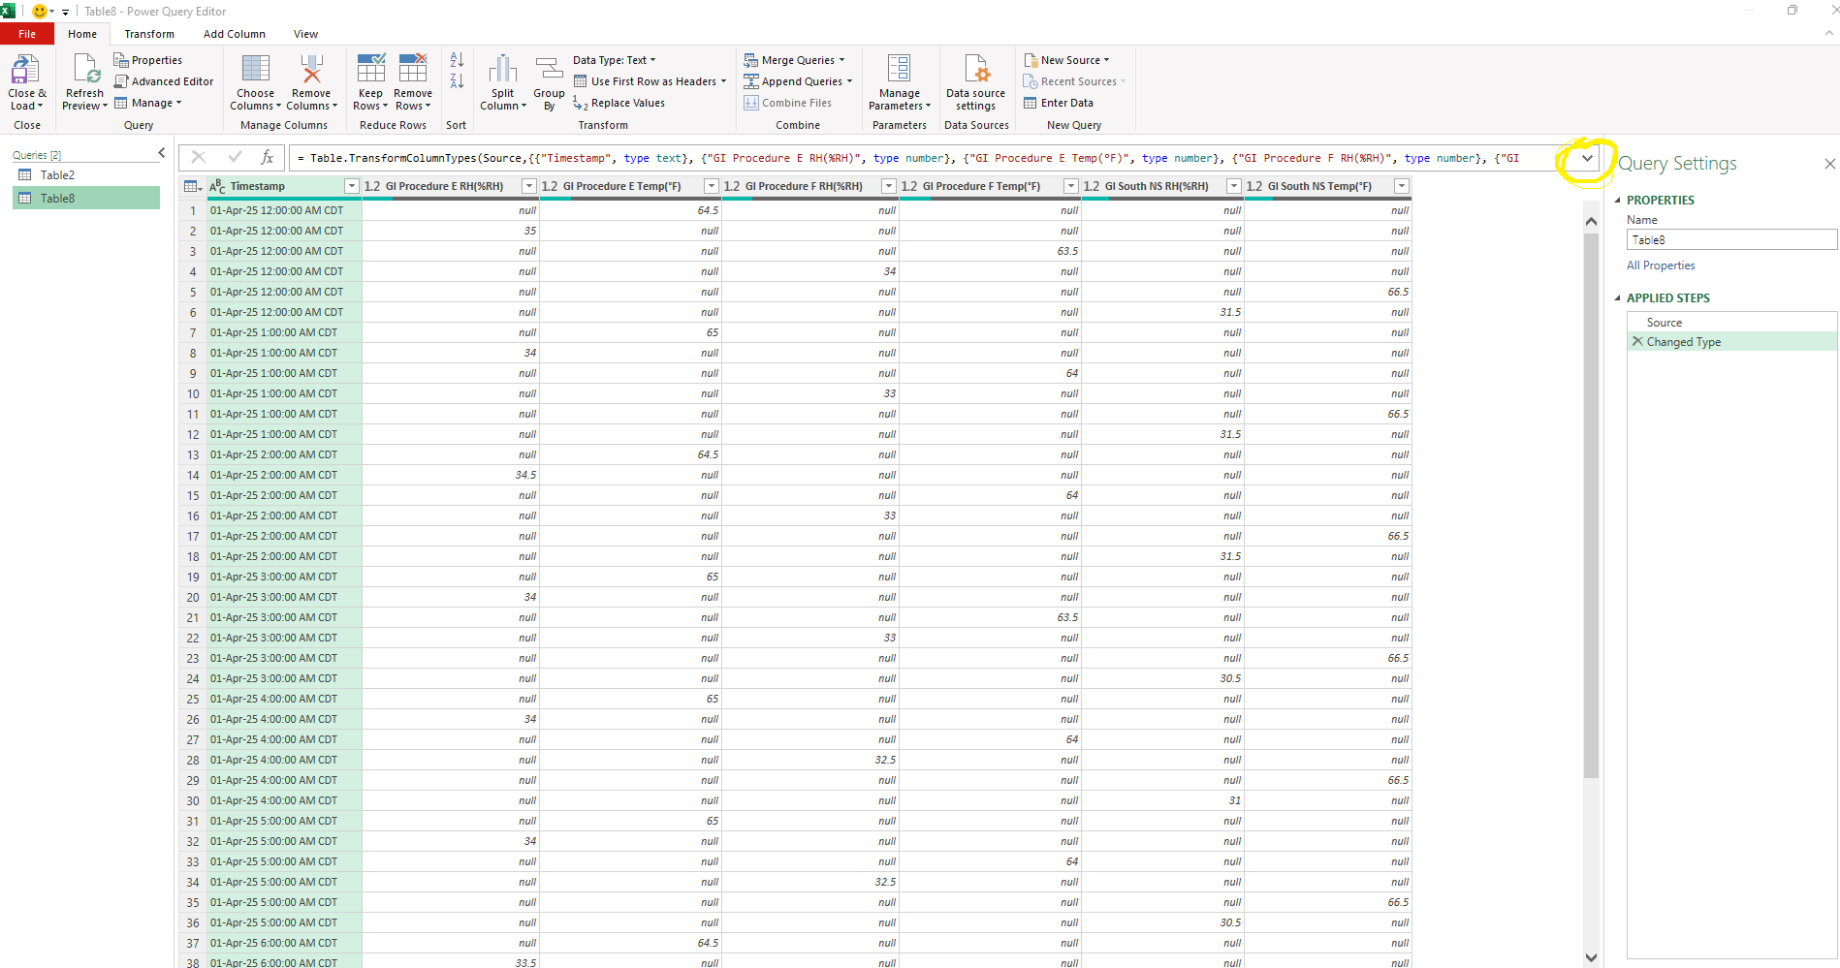

* 1. Power query function

***= Table.Group(Source, {"Timestamp"}, {***

***{"GI Procedure E RH(%RH)", each List.Max(List.Select([#"GI Procedure E RH(%RH)"], each _ is number)), type nullable number},***

***{"GI Procedure E Temp(°F)", each List.Max(List.Select([#"GI Procedure E Temp(°F)"], each _ is number)), type nullable number},***

***{"GI Procedure F RH(%RH)", each List.Max(List.Select([#"GI Procedure F RH(%RH)"], each _ is number)), type nullable number},***

***{"GI Procedure F Temp(°F)", each List.Max(List.Select([#"GI Procedure F Temp(°F)"], each _ is number)), type nullable number},***

***{"GI South NS RH(%RH)", each List.Max(List.Select([#"GI South NS RH(%RH)"], each _ is number)), type nullable number},***

***{"GI South NS Temp(°F)", each List.Max(List.Select([#"GI South NS Temp(°F)"], each _ is number)), type nullable number}***

**})**

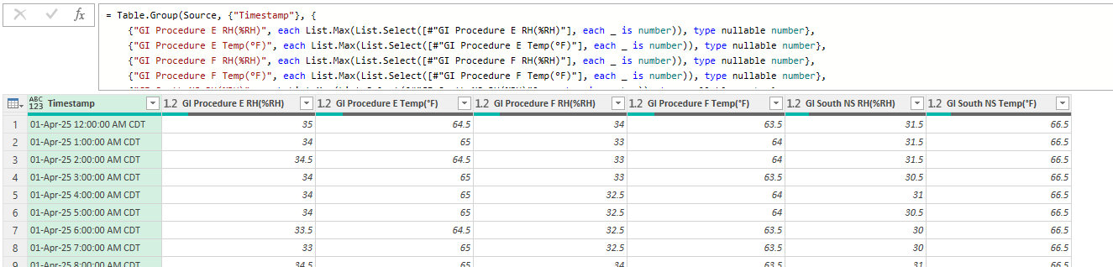

1. After pasting the function, select the "Check Mark"

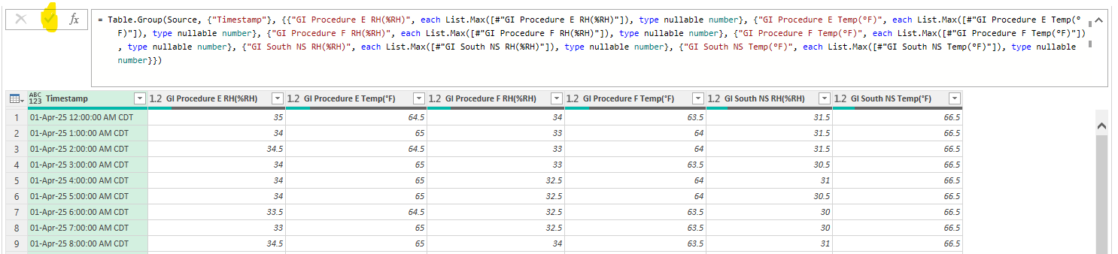

1. Click "Close & Load" at the top

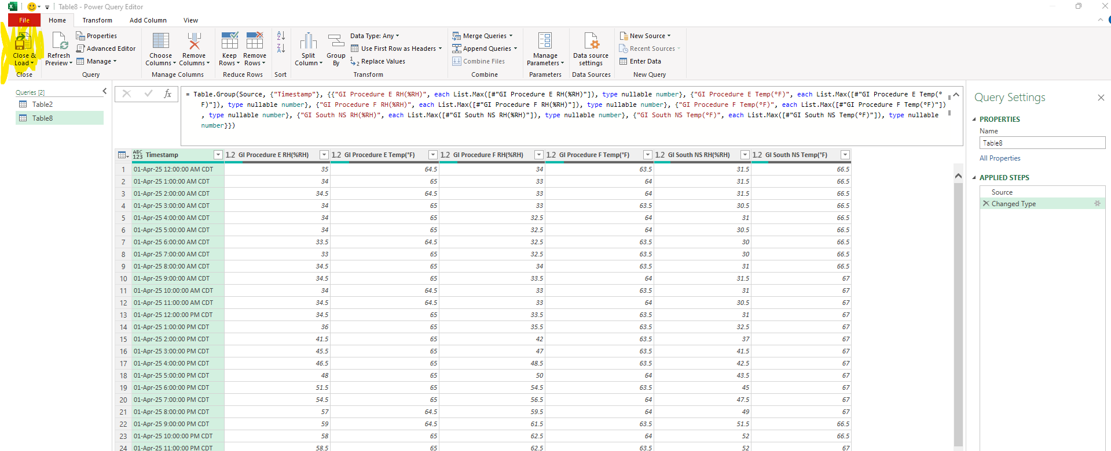

1. The data should be in order of time with no null/empty cells all in a new sheet in excel
   1. Name new sheet “(Current Month) GI E&F Edited Data”
2. Rename original sheet “(Current Month) GI E&F Raw Data”

|  |
| --- |
|  |

1. Select newly created sheet
2. Create new column named "Out of Range?"
3. Type this formula into the first cell below column title ("H2)
   1. =IF(OR(OR(OR(B2<10, B2>90),OR(D2<10, D2>90),OR(F2<10, F2>90)),OR(OR(C2<59, C2>86),OR(E2<59, E2>86),OR(G2<59, G2>86)),"Out of Range","")

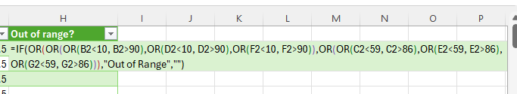

* 1. Press “Enter” on keyboard to confirm function in cell
  2. The function should populate for all

1. Will put “Out of Range” if any of the recorded humidity or temps are out of range



* 1. Entries within temp and humidity range will be empty

|  |
| --- |
|  |
|  |

1. In the Edited Data sheet, insert a line above the header and merge all the new columns
   1. Give a title to the sheet
      1. ‘Month’ ‘Year’ GI Procedure E&F New MPP Temp and Humidity Log
         1. Bold, 20 font



1. Make the headings row appear on all printed sheets
   1. Select the row with the headings
   2. Go to ‘Page Layout’ tab

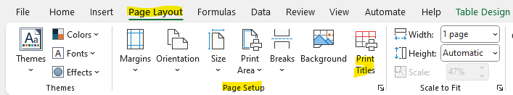

* 1. Select ‘Print Titles’ from ‘Page Setup’ section
  2. In ‘Rows to repeat at top:’, row 2 should be listed as below

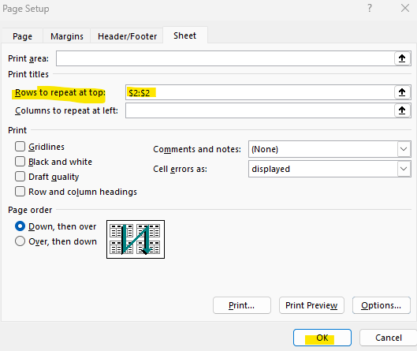

* 1. Select ‘OK’

|  |
| --- |
|  |

1. Print the document.